

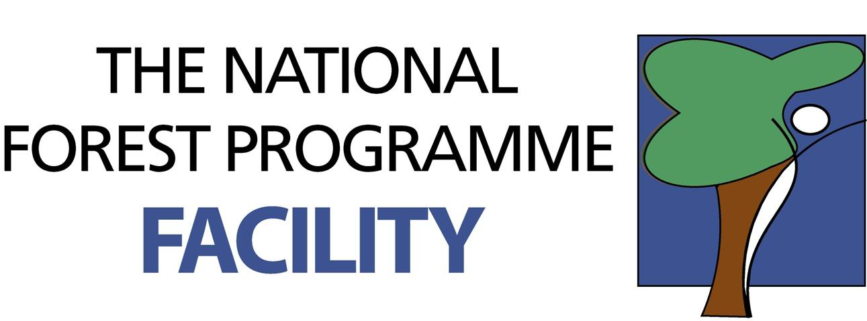

Working Document for Forests and Livelihoods Action Learning Group (ALG)

Definitions of key concepts

Caribbean Natural Resources Institute (CANARI)

The ALG has developed consensus on the following elements of key concepts (with areas of debate highlighted in italics):
Institutional arrangements: comprise both ‘the rules of the game’ and ‘the players’. They can occur at all levels and can be formal, permanent or transitory. The arrangements can be between people, policies, legislation, practices, culture, organizational structures, design and processes.
Livelihoods: the capabilities, assets (including both material and social resources) and activities required for developing a living. It was suggested that people’s aspirations in relation to livelihoods should be factored into the definition and that livelihoods should not be seen merely as reaching subsistence level.
The DFID livelihoods framework (Figure 1) offers a useful way of assessing social and economic impacts, and it is reasonably easy to establish a baseline that can be monitored for change.
Human

Natural

Political

Financial

Physical

Social

Figure 1. Livelihoods framework
Livelihood Assets
The main forms of capital/assets which are being examined under the programme in relation to the assessment of socio-economic benefits are:
- Natural (ownership or access to natural resources, including land, water, and ecosystem services)
- Human (related to individual capabilities, skills, talents, health, education)
- Physical (standard of housing, access to transportation, infrastructure, amenities, equipment)
- Political (power, access to and influence over decision-making processes, presence of a democratic system, polarisation in politics which may have financial impacts)
- Financial (income, savings, investment, access to credit, inheritance, material)
- Social (family, community and relationships built through social networks)
In general, the greater amount and diversity of assets, the greater the level of well-being and resilience to change and shocks.
The framework however does not take account of “intangibles” that can also determine the level of vulnerability and resilience of the poor. These include the amount of respect they are given; the level of trust they can expect in their dealings with others, including government; and the qualities of attitude and personality that also determine their adaptability, initiative, and ability to deal with disasters and shocks. When employing the livelihoods framework to assess livelihood impacts, these intangibles should also be taken into account.
Livelihoods are sustained when they generate sufficient resources to support livelihoods indefinitely, i.e. they are resilient to stress and shocks, do not compromise the productivity of the resource base and do not undermine the livelihoods of others. A balanced mix of the 6 livelihood assets contributes to sustainability by increasing resilience to shocks and stress. The unresolved area of debate was whether sustainable livelihoods must also eliminate dependence on external support.
Tradeoffs for resource use and livelihoods include: livelihood security versus natural resource sustainability; maximising present income versus reducing vulnerability to future shocks; enhancing individual livelihoods versus protecting the livelihoods of others.
Forests are areas with certain physical attributes (which still need to be defined more precisely for the Caribbean context) that provide forest goods and ecosystem services and have cultural acceptance as forests, i.e. “forests are what people say they are”. However, it was also agreed that the technical definitions of ‘forests’ are important but that non-specialists would need more explanation and clarification of them in order for them to be useful . For example, it is important for people to recognise that what they refer to as ‘bush’ (degraded forests) or mangroves are also forests. It was felt that a broader perception of forests must be promoted, whereby people define forests and forest resources in terms of their value. This would also encompass livelihood definitions, as people consider what they have at their disposal and how it is useful to them in their daily lives – the livelihood assets.
Forest management is the art and science of managing forests in a purposeful and objective driven manner. The objectives include provision of goods and services that provide benefits to people and sustaining the functions of the forest.
Rural Poor: There was limited agreement on how to define rural poor. Participants felt that the terms “rural” and “poor” should be looked at separately, particularly since there is a strong cultural perception in the Caribbean about who is considered urban, rural and poor regardless of physical location and income levels. It was suggested that examination was needed of the external forces that could put someone at risk of being poor. Also that consideration should be given to levels of nutrition and health when developing the definition of “poor”. It was suggested that the definition should not be confined just to the characteristics of rural poverty but also to the processes and changes that affect poverty and the ability to earn an income. It was agreed that the project team should review international definitions and then develop a broad conceptual framework for the project, which would then be further refined with the participation of project stakeholders.

Stakeholders

Participatory forest management

